General summary of the data
The dataset from Kaggle combines an assortment of patient data collected through Sanger Institute collaborated with the Massachusetts General Hospital Cancer Center. All data from these sources are combined in the GDSC_dataset in Kaggle. The dataset is the result of a large-scale screening of cancer cell lines treated with a range of anti-cancer drugs. Cell viability was measured within 72 hours after beginning treatment. The dataset contained a large number of missing values that were replaced with outside data.
The Cell Line Encyclopedia was used to help cross-fill the missing or weak labels from the column containing The Cancer Genome Atlas (TCGA) values.^{[5]} These were taken from validated sources, such as hospital records, and only replaced the columns that returned UNCLASSIFIED (missing values) when the supporting evidence pointed to one clear biological category. New numerical features were also added from the supplementary datasets from the depmap; mutational_burden, ploidy_snp6, and ploidy_wes; and were also imputed to preserve the sample size.^{[5]} The TARGET (values of specific agents within the cells that the drugs attacked to reduce cancer) column was removed due to its large number missing values, which could not be reliably recovered from the supplementary files.

Data quality summary
The original data sourced from the Sanger Institute combines drug response data with genomic profiles of cancer cell lines to allow for analysis of the relationship between genetic features and drug sensitivity. The original dataset's dimensions were 242,035 rows by 19 columns. After preprocessing, the final dimensions were 242,035 rows by 22 columns. This data included a range of feature types with the target variable being LN_IC50 which serves as a measure of cancer drug sensitivity. To refine the model, feature selection was conducted using baseline mutual-information analysis combined with repeated subsample-based selection. 9 of the 22 features were used during modeling. These features include LN_IC50, DRUG_NAME, TCGA_DESC, GDSC Tissue descriptor 1, GDSC Tissue descriptor 2, MSI, Growth Properties, TARGET_PATHWAY, mutational_burden, ploidy_snp6 and ploidy_wes.
Dealing with missing values was a critical component of the preprocessing stage; key features like TCGA_DESC, tissue descriptors, MSI and related features had inconsistent or incomplete values. These gaps were primarily filled using the additional datasets associated with the study by matching the COSMIC_ID of each row, as COSMIC_ID is a universal key.^{[1]} Additionally, the TCGA_DESC contained the cancer-type labels, but it also included the non-biological category of UNCLASSIFIED, which accounted for nearly 20% of the dataset. This issue was resolved by applying a staged recovery process that cross-filled missing or weak labels from validated supplementary sources, used reviewed cell-line remaps where appropriate, and only replaced UNCLASSIFIED when the supporting evidence pointed to one clear biological category. Three new numerical features were also added from the supplementary datasets; mutational_burden, ploidy_snp6, and ploidy_wes; and were also imputed to preserve the sample size. The TARGET was removed due to its missing values, which could not be reliably recovered from the supplementary files.
After cleaning and augmentation, the feature-engineering stage transformed the selected predictors into a model-ready format while preserving interpretability (fig. 1). The IC50-based response had served as a standard endpoint in GDSC analyses and had also been used directly in prior predictive modeling studies built from the same resource, LN_IC50 was retained as the main target variable. The data was then divided using an 80/20 train-test split so that later transformations were learned only from the training data and data leakage was avoided. Categorical predictors were one-hot encoded, while the high-cardinality DRUG_NAME feature was target encoded so that drug identity could be represented as a single informative numeric variable without creating an overly sparse feature space. The continuous predictors such as mutational_burden and ploidy_wes were then standardized, which changed feature magnitude while preserving distributional shape. Finally, mutual-information feature selection was used to rank predictors by their relationship with LN_IC50, and the strongest retained variables included the encoded drug feature together with the augmented genomic features, showing that the added biological variables contributed meaningful predictive signals rather than noise.
There are three different metrics used to compare models: root mean squared error (RMSE), mean absolute error (MAE), and R² . Both the MAE and RMSE are in the same units as the target variable, making them easily comparable to each other. RMSE penalizes large errors more heavily than the MSE, which is important in the context of this project because large deviations can have a significant impact on the interpretation of biological data and drug potency. The MAE is less sensitive to outliers than the RMSE, so provides a better measure of typical error. R² is the coefficient of determination; a measure of model fit independent of scale and gives good context for overall model performance. So, the overall interpretation of model performance is mostly determined by R² and further informed by MAE and RMSE. A well-performing model will have a low RMSE and MAE, with a small difference between the two, and a high R². There are moderate differences between the MAE and RMSE across all models which indicates the presence of significant outliers in the LN_IC50 data.
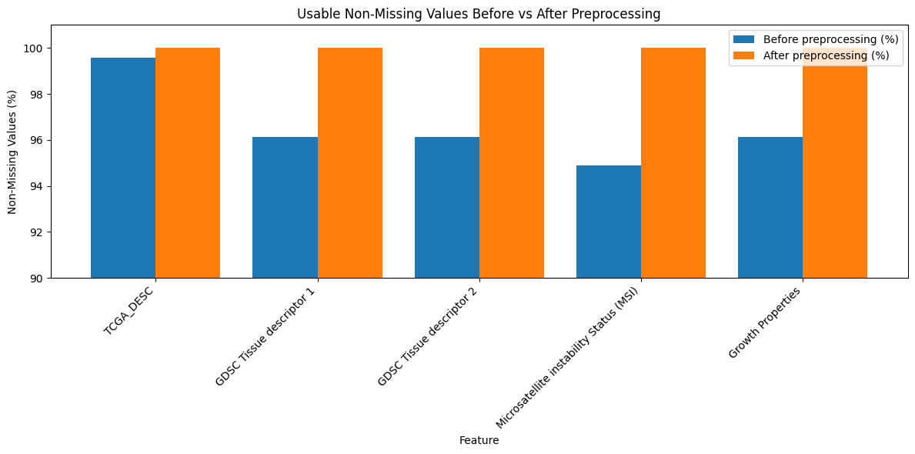Figure 1: Percentage of values in key features before and after preprocessing, showing that filling and imputation substantially improved the dataset.
Target variable
The project had three options to be chosen as the target variables for drug-response interpretations: AUC score (Area Under the Curve measure of drug effectiveness), LN_IC50 score (the natural log of the concentration of the drug needed to inhibit 50% of the cancer cells), and the Z-score (standardized score of the drug response). Figure 1 shows that the AUC was highly compressed near its upper boundary, which limits usable variation for regression models, while the LN_IC50 showed a broader and more continuous spread which would be beneficial to the models. The Z-score appears to be the most centered and statistically clean, but while it is a standardized measure, it is less interpretable compared to the LN_IC50 values. Figure 2 supports this idea by showing that LN_IC50 preserves a wider and more informative range of response values, even though some outliers remain, which is expected in biological data.
Figure 4 strengthens this by showing the LN_IC50 and AUC as strongly correlated, with both correlations getting an R score of 0.76, indicating the LN_IC50 still would capture much of the drug response signal represented by AUC. Z-score correlation, compared to the AUC and LN_IC50, only had moderate correlations with both LN_IC50 and AUC, suggesting it behaves more as a secondary standardized comparison measure than the most direct biological endpoint. All these make LN_IC50 a strong candidate for the target variable, considering it combines a wider usable spread with stronger biological meaning, since it directly reflects the drug concentration needed to inhibit cancer cell growth.

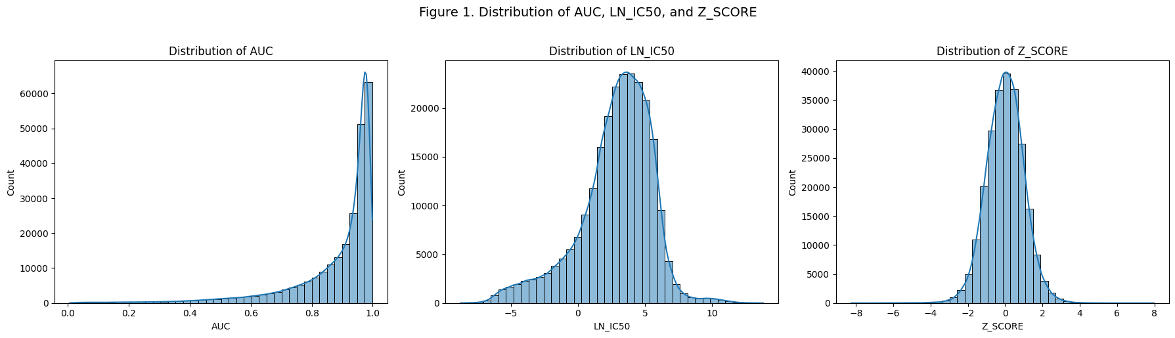
Figure 2: Distribution of Candidate Drug Response Variables; LN_IC50 shows a broader spread than AUC and Z_SCORE.

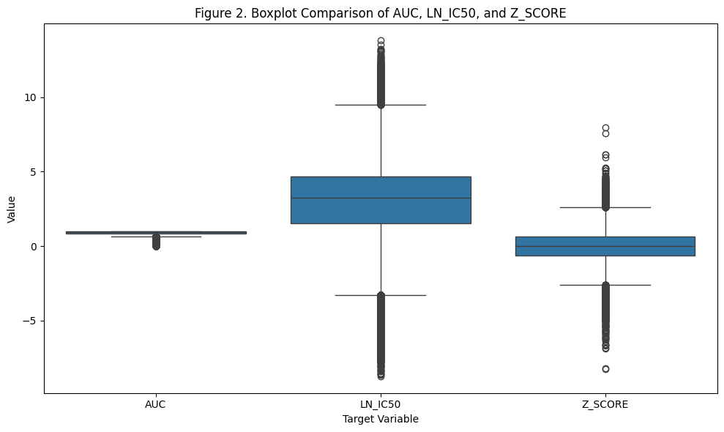
Figure 3: Boxplot Comparison of Candidate Drug Response Variables; LN_IC50 retains wider variation across observations.
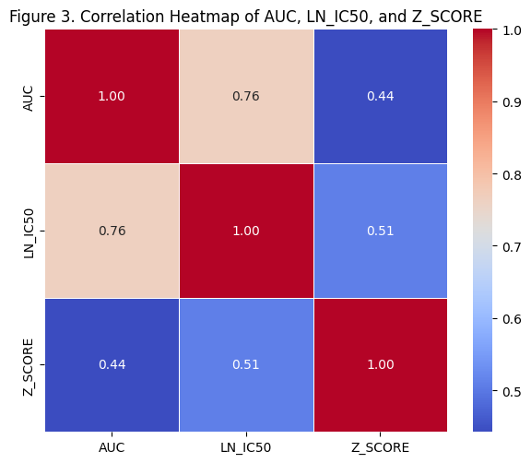
Figure 4: Correlation Among Candidate Drug Response Variables; LN_IC50 strongly aligns with AUC response signal.

Individual variables
The modeling dataset contains variables related to drugs, cancer cell lines, phenotypes, and genomics that help explain variation in LN_IC50, the continuous drug-response target used in this project. These variables were selected because they capture complementary information about the treatment, the biological context of the cell line, and the genomic state of the sample.

Drug-related variables
DRUG_NAME identifies the compound applied to each cell line. It is a high-cardinality categorical feature with many unique values, which would lead to sparsity if encoded using standard one-hot encoding. In the preprocessing pipeline, DRUG_NAME is transformed using target encoding, where each drug is represented by the mean LN_IC50 computed from the training data. This produces a compact numeric feature (DRUG_NAME_target_enc) that captures drug-specific response patterns while avoiding high dimensionality.
TARGET_PATHWAY describes the biological pathway or mechanism associated with the drug's target. This feature was retained because it provides a broader and more stable representation of the drug mechanism than the granular TARGET variable. Figure 4 illustrates the LN_IC50 distribution across these pathways, showing distinct drug sensitivity profiles. For example, pathways such as cell cycle and DNA replication exhibit lower median LN_IC50 values, indicating higher sensitivity, compared to the Other category, confirming that this variable captures critical pathway-level differences in drug sensitivity.

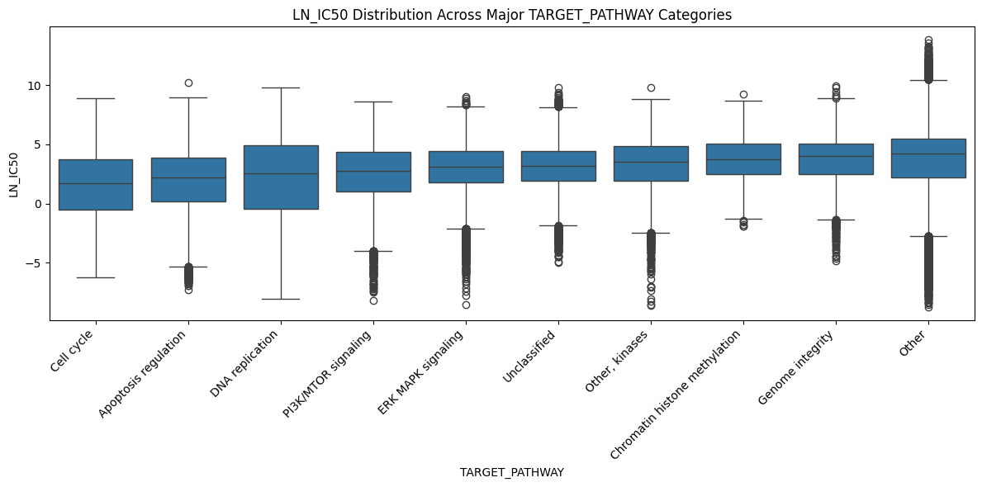
Figure 5: LN_IC50 Across Major TARGET_PATHWAY Categories; Drug response varies across major target-pathway groups.

Cancer-type variables
TCGA_DESC is the primary cancer-type label in the cleaned dataset. It represents the TCGA-aligned classification of each cell line and was systematically harmonized during preprocessing to improve consistency across data sources. Missing values were recovered using supplemental datasets when reliable mappings were available. Additional normalization steps were applied, including reassigning ambiguous labels (e.g., OTHER) and resolving UNCLASSIFIED entries using consensus mappings derived from auxiliary metadata. This ensures that TCGA_DESC is both consistent and biologically meaningful.

GDSC Tissue descriptor 1 and GDSC Tissue descriptor 2 provide broader and more specific tissue annotations for each cell line. These variables complement TCGA_DESC by capturing tissue-of-origin information at different levels of granularity. As shown in Figure 5, the preprocessing pipeline successfully addressed initial missingness in these descriptors by using a COSMIC_ID-based lookup table, where multiple records per cell line were aggregated using a first non-null strategy. This approach improves data coverage while preserving consistency.

Experimental and phenotype variables
Microsatellite instability Status (MSI) indicates whether a cell line exhibits microsatellite instability or is microsatellite stable. This is a biologically meaningful categorical feature, as MSI is associated with defects in DNA repair and increased genomic instability, which can influence drug response. During preprocessing, missing MSI values were first filled using supplemental datasets, and any remaining missing values were assigned an explicit "MISSING" category to preserve potential information in missingness.

Growth Properties describes how the cell line grows in culture. Although it is not a direct biological driver of drug response, it captures phenotypic and experimental context that may indirectly influence observed response patterns. Missing values were filled using supplemental datasets, and the variable was retained as a categorical predictor.

Genomic variables
mutational_burden is a continuous feature representing the number of mutations observed in a cell line. It serves as a proxy for genomic instability, which can affect cellular pathways and heterogeneity, thereby influencing drug sensitivity. The variable was converted to numeric form, imputed using the median, and retained as a continuous predictor.
ploidy_snp6 and ploidy_wes are continuous estimates of chromosome copy number derived from SNP array and whole-exome sequencing data, respectively. These features capture large-scale genomic alterations characteristic of cancer that may impact drug response. Both variables were imputed using the median and treated as continuous predictors.

Identifier variables
COSMIC_ID, CELL_LINE_NAME, and DRUG_ID are identifier fields rather than explanatory variables. They are essential for linking records across datasets and maintaining traceability during preprocessing, but they do not contain meaningful predictive information and are not used as model inputs.
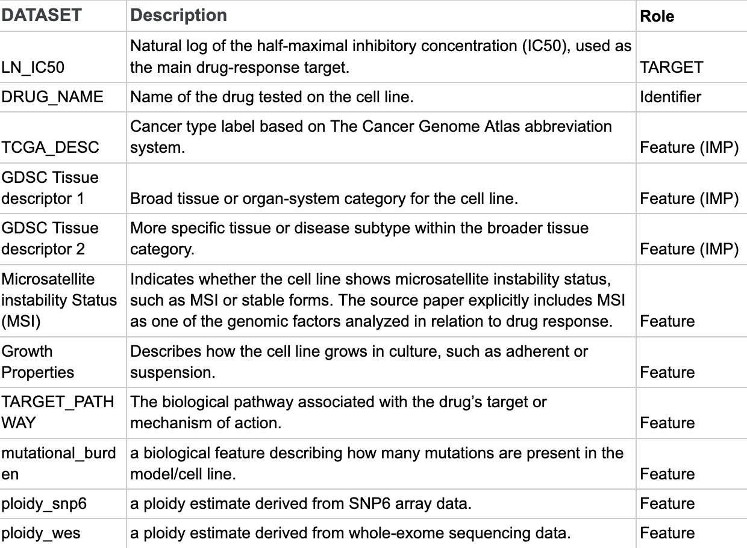
Figure 6: Above is a chart of the different variable types used in the project and what they mean.
Missing Values
The effectiveness of the data recovery strategy for these categorical variables is summarized in Figure 1. While several variables (most notably MSI and the GDSC Tissue descriptors) exhibited missingness rates near 5% before preprocessing, the final modeling set achieved 0% missing data across all retained categorical features.

Variable ranking
As we have too many features to list all of them here, we determined the top 8 most important features based on their influence on the LN_IC50. Ranking and feature selection was done using baseline mutual information analysis combined with repeated subsample-based selection. The mutual information ranking suggested that the drug name is by far the strongest predictor of the target variable. In descending order after that, the genomic features ploidy_wes, ploidy_snp6, and mutational burden follow, then pathway, growth, tissue, and TCGA descriptors. Many other variables were included, and the comprehensive list in Figure 6 breaks features down even more.

Relationship between explanatory variables and target variable
Feature selection was applied to identify the most important predictors of LN_IC50. Using statistical and model based methods, drug related features such as the encoded drug variable (DRUG_NAME_target_enc) and TARGET_PATHWAY were consistently ranked as the most influential. These variables capture differences in drug mechanisms and response behavior, which directly affect drug sensitivity.
Cancer related variables including TCGA_DESC and GDSC tissue descriptors, showed moderate importance in feature selection results. These features help explain variation across different cancer types and biological contexts. Genomic features such as mutational_burden and ploidy variables were selected with lower importance scores but still contributed meaningful information by reflecting underlying biological variation between cell lines
Categorical variables were handled using a combination of target encoding and one-hot encoding. The high cardinality feature DRUG_NAME was transformed using cross validation target encoding, where each category was replaced with the mean LN_IC50 value calculated from the training data. This approach reduces dimensionality while preserving meaningful relationships between drugs and the target variable.
All remaining categorical variables, including TCGA_DESC, TARGET_PATHWAY, GDSC tissue descriptors, Microsatellites instability status, and Growth Properties, were encoded using one-hot encoding. This method converts each category into a binary feature, allowing the models to interpret categorical differences without introducing ordinal bias. These preprocessing steps ensured that categorical variables were transformed into a numerical format suitable for machine learning models while maintaining their underlying biological and clinical meaning.
Overall, feature selection results confirm that LN_IC50 is primarily driven by drug specific characteristics, while cancer type and genomic features provide additional context that improves predictive performance.

Feature Selection
The 4 feature selection figures show how the selected prediction set changed from the baseline stage to the final model stage. In both stages, DRUG_NAME_target_enc remained the strongest feature, confirming that drug identity carried the largest relationship with LN_IC50. However, the final feature selection ranking seems more balanced, with stronger visible contributions from growth-property, tissue-descriptor, and cancer-context features. The correlation heatmaps in Figure 8 show that most selected variables have low-to-moderate correlation with each other, meaning the retained features are not simply duplicates of the same signal. These figures suggest that the feature set captures multiple data dimensions like drug identity, genomic instability, growth behavior, pathway information, and tissue or cancer context, while keeping redundancy relatively controlled.
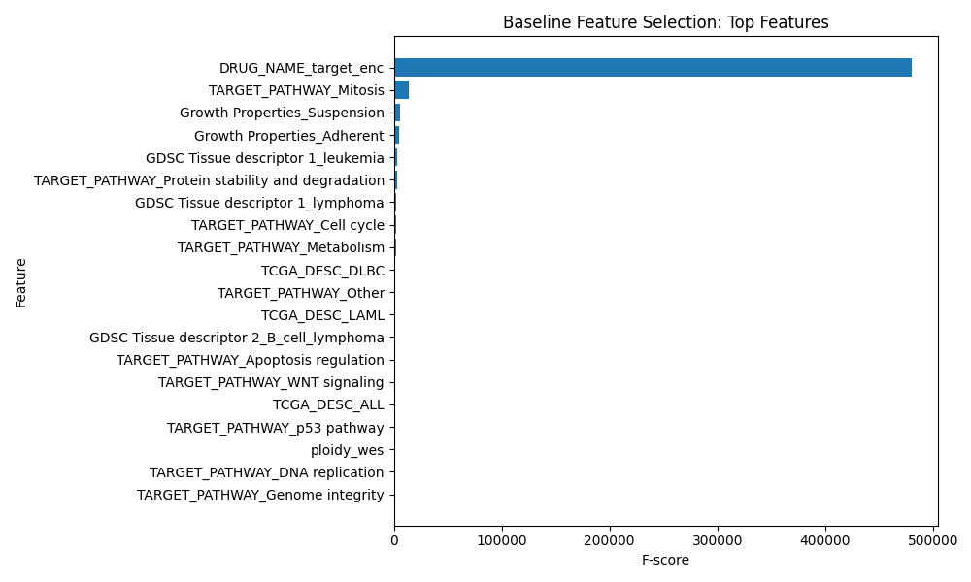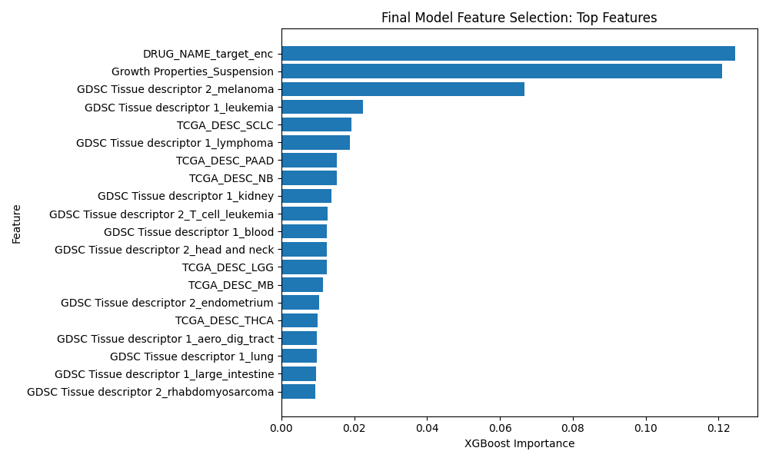
Figure 7: Feature Selection Rankings for Baseline and Final Models; Compares the top selected predictors from the baseline and final model stages, showing that DRUG_NAME_target_enc remains dominant while the final model gives stronger visible weight to growth and tissue-context features.
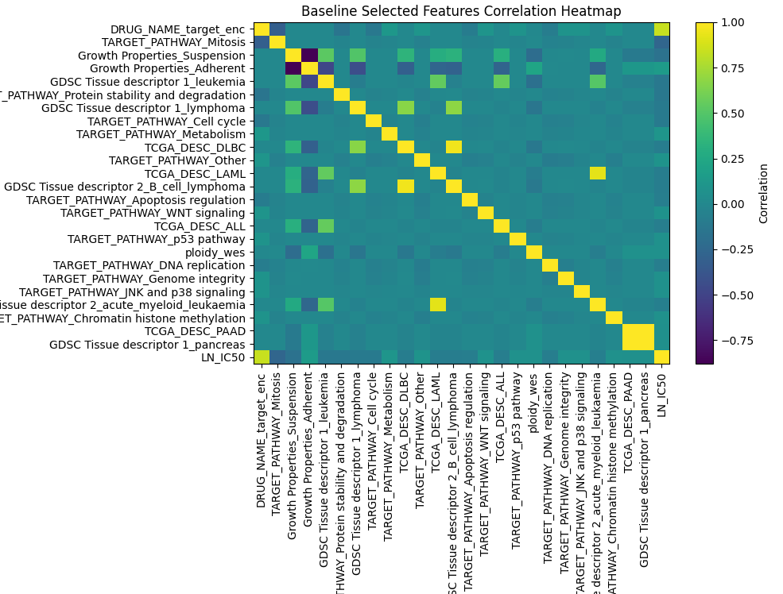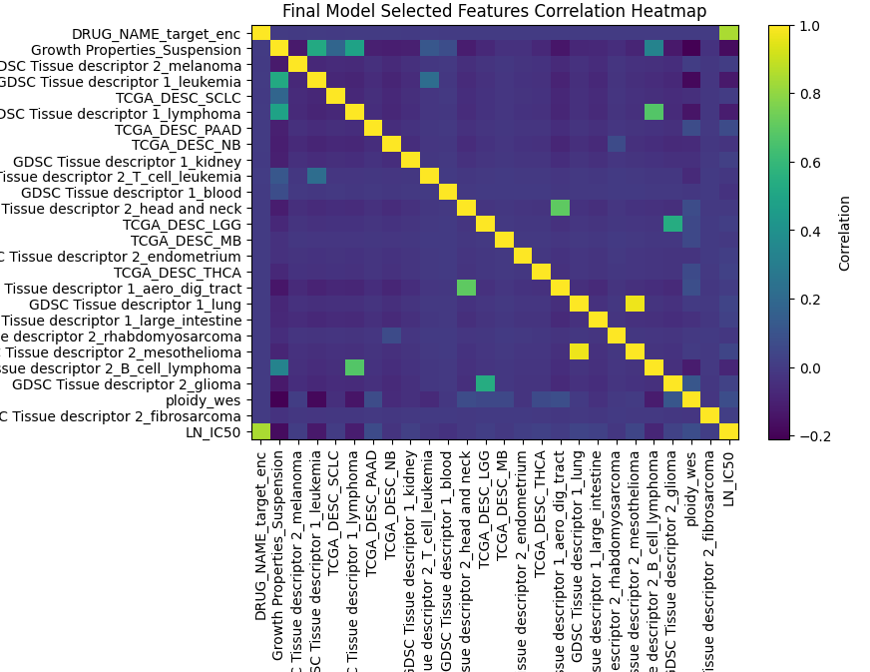
Figure 8: Selected Feature Correlation Heatmaps for Baseline and Final Models; Compares correlations among selected baseline and final features, showing mostly low-to-moderate redundancy across drug, growth, tissue, pathway, and cancer-context predictors.

Citations

- Garnett, Mathew J., et al. “Systematic identification of genomic markers of drug sensitivity in cancer cells.” Nature, vol. 483, no. 7391, Mar. 2012, pp. 570–575, https://doi.org/10.1038/nature11005.
- Menden, Michael P., et al. “Machine learning prediction of cancer cell sensitivity to drugs based on genomic and Chemical Properties.” PLoS ONE, vol. 8, no. 4, 30 Apr. 2013, https://doi.org/10.1371/journal.pone.0061318.
- Gao, Qing, et al. “The artificial intelligence and Machine Learning in lung cancer immunotherapy.” Journal of Hematology &amp; Oncology, vol. 16, no. 1, 24 May 2023, https://doi.org/10.1186/s13045-023-01456-y.
- Cavallari, Larisa H. & Johnson, Julie A. (2023). Use of multi-gene pharmacogenetic panel reduces adverse drug effects. Cell Reports Medicine, 101021. https://www.cell.com/cell-reports-medicine/fulltext/S2666-3791(23)00131-3?_returnURL=https%3A%2F%2Flinkinghub.elsevier.com%2Fretrieve%2Fpii%2FS2666379123001313%3Fshowall%3Dtrue
- (2025). Cancer Cell Line Encyclopedia. Depmap Portal. https://sites.broadinstitute.org/ccle/

